Міністерство освіти і науки України

Національний технічний університет України «Київський політехнічний

інститут імені Ігоря Сікорського"

Факультет інформатики та обчислювальної техніки

Катедра інформатики та програмної інженерії

Звіт

з лабораторної роботи № 1 з дисципліни

«Компоненти програмної інженерії. Частина 3.

Архітектура програмного забезпечення»

«Формування вимог до додатку»

Виконали студенти ІП-11 Лесів Владислав, Прищепа Владислав

Перевірив Баришич Лука Маріянович

Київ 2023

**Лабораторна робота 1**

**Формування вимог до додатку (System requirements)**

**Мета**: вибрати проєкт для розробки. Познайомитись з варіантом опису вимог до додатку за допомогою user stories та познайомитись з інструментами для побудови wireframes.

**Завдання:**

1. Вибрати тему роботи;
2. Для обраної теми визначити основний функціонал (features), який має бути розроблено;
3. Для кожного функціоналу описати “історії користувачів” (user stories);
4. Сформувати шаблони сторінок (wireframe) для обраного функціоналу.

**Критерії:**

1. У роботі має бути не менше 5 доменів (домен із Domain driven design);
2. У роботі має бути інтеграція із мінімум 2 зовнішніми системами.

**Хід роботи.**

1. Application: E-commerce platform for a furniture store (Платформа е-комерції для магазину меблів)

Platform: mobile, Android.

Domains: Sales, Inventory, Customer, Product, Shipping

External systems: Payment gateway, Shipping provider

1. Features.

Feature 1: simple flow to order a furniture (for a customer);

Feature 2: simple flow to accept order (for a manager);

Feature 3: simple flow to check the stock availability (for a manager);

Feature 4: simple flow to create a postal invoice and confirm the shipment (for a manager);

1. User Stories.

Authorization:

1. As a client I want to be able to sign up entering all my info so that all necessary information needed for my order autocompletes.

Acceptance criteria:

Fields must include Name and Surname, E-mail, password.

1. As a client I want to sign in with my account info so that I can make my order.
2. As a manager I want to sign in using my work account so that I can access to manager tools.

Acceptance criteria:

Required fields: E-mail and password.

Feature 1: simple flow to order a furniture (for a customer).

1. As a client I want to be able to choose desired furniture so that I can make my order.

Acceptance criteria:

Search field should be autocomplete field with list of furniture.

1. As a client I want to be able to choose quantity of chosen furniture so that I can receive the ordered items in the required quantity.

Acceptance criteria:

Quantity field should be counter field with a value of 1 by default.

1. As a client I want to be able to see the price of chosen furniture before adding it to shopping cart so that I can decide if it’s ok for me to buy this thing for such price.

Acceptance criteria:

Price should be shown as soon as furniture is defined and should be updated when counter field of quantity is updated.

1. As a client I want to be able to see my shopping cart and its total before confirming the order so that I can decide if it’s ok for me to order for such price.

Acceptance criteria:

Added items and cart total should be shown as soon as shopping cart icon is clicked.

1. As a client I want to be able to remove items from the shopping cart so that I can order only things that I actually need.

Acceptance criteria:

It should be possible to delete a single item by clicking on the button next to it, as well as to delete the entire cart.

1. As a client I want to be able to pay for the order online so that I can pay the store for the provided goods.

Acceptance criteria:

There should be options to pay using Google Pay\Apple Pay, Privat24 or entering card details.

1. As a client I want to be able to enter the delivery address so that I can receive the items in a convenient place.

Feature 2: simple flow to accept order (for a manager);

1. As a manager I want to see all available orders so that I can choose the one to process.

Acceptance criteria:

The manager should see the list of goods ordered by the customer.

1. As a manager I want to cancel my acceptance on the order so that another manager could accept it and save my and clients time.

Feature 3: simple flow to check the stock availability (for a manager).

1. As a manager I want to be able to choose desired furniture from order list so that I can see information about it.

Acceptance criteria:

The manager should see the list of goods ordered by the customer.

1. As a manager I want to be able to see amount of chosen piece of furniture available in the stock so that I can understand what to do.
2. As a manager I want to be able to order certain number of pieces of chosen furniture so that I can sent it to customer if it is necessary.

Feature 4: simple flow to create a postal invoice and confirm the shipment (for a manager).

1. As a manager I want to be able to create a postal invoice so that I can inform customer about overall price of the order.
2. As a manager I want to be able to confirm the shipment so that I can sent postal invoice with the order to the client.
3. Wireframes.
4. Authorization:

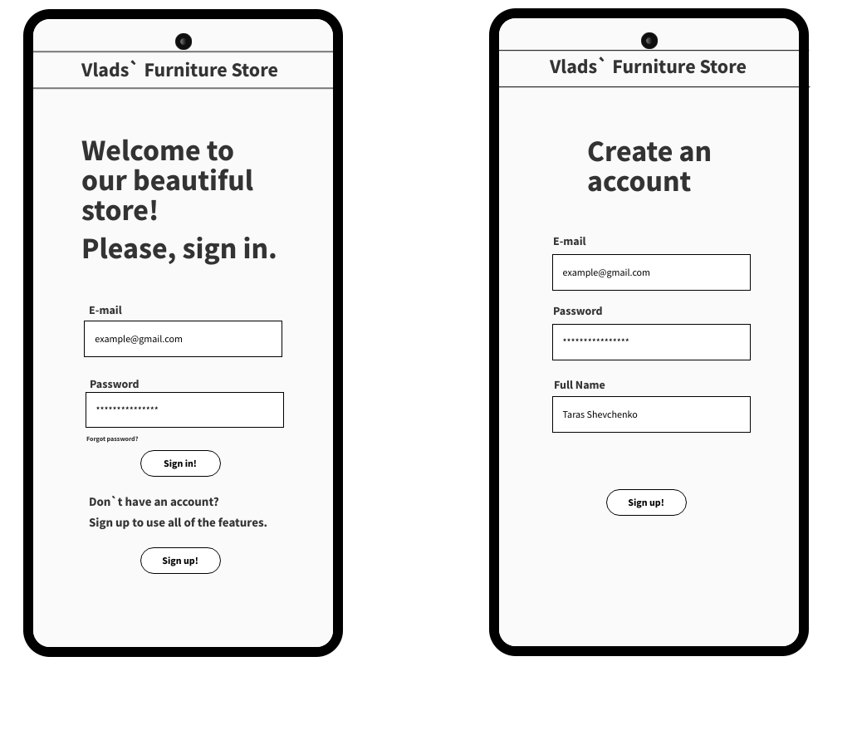

1. Feature 1: simple flow to order a furniture (for a customer).

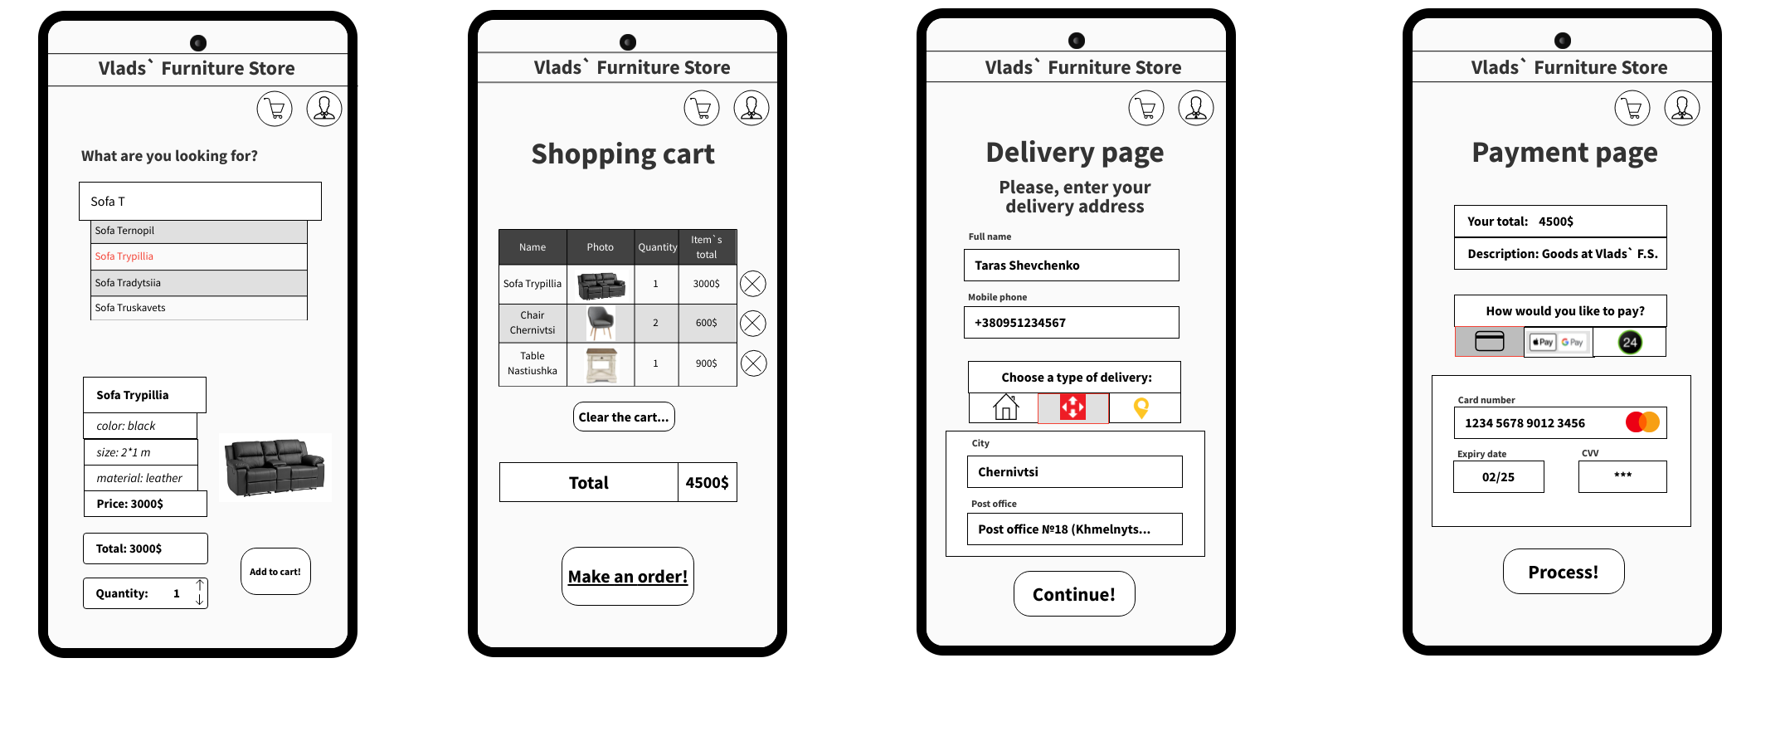



1. Feature 2: simple flow to accept order (for a manager);

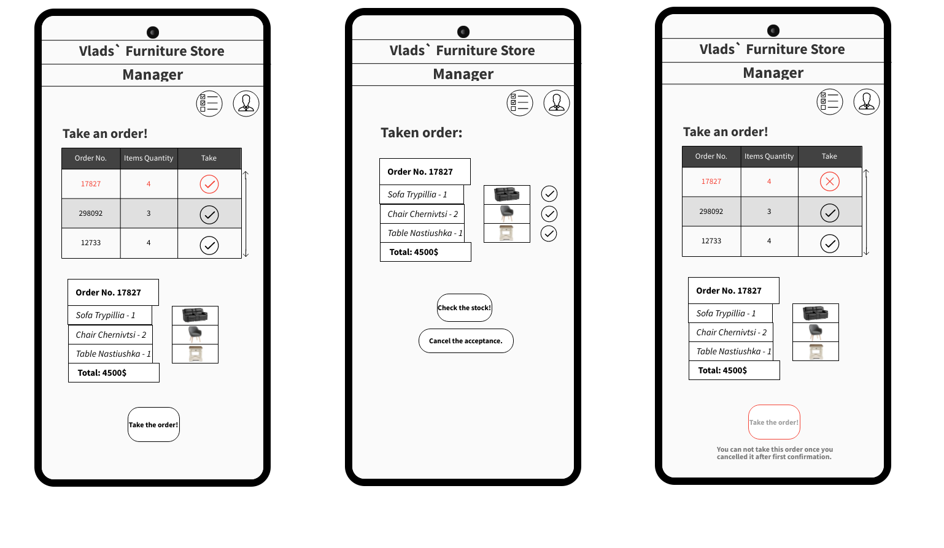

1. Feature 3: simple flow to check the stock availability (for a manager).

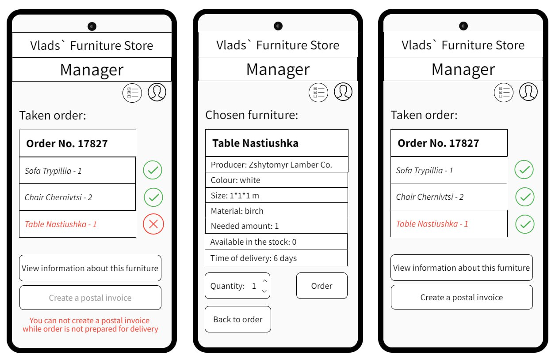

1. Feature 4: simple flow to create a postal invoice and confirm the shipment (for a manager).

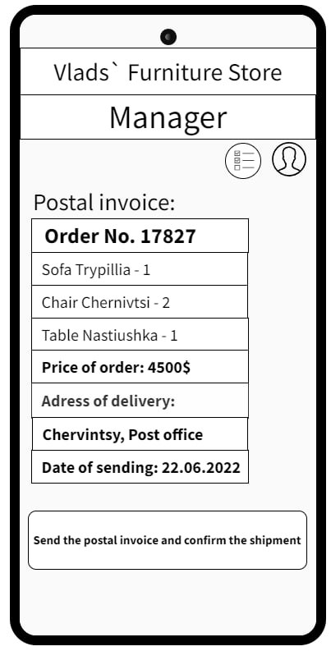 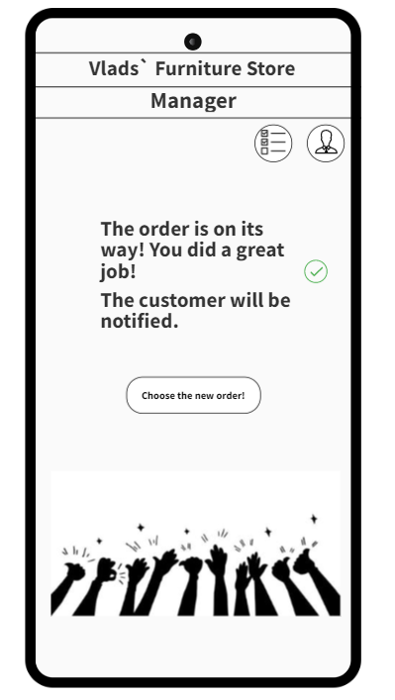

**Висновок.**

Отже, у цій роботі ми отримали навички формування вимог до додатку. У результаті лабораторної роботи було вибрано проєкт для розробки - Платформа е-комерції для магазину меблів, також ми ознайомились з варіантом опису вимог до додатку за допомогою user stories та познайомились з інструментами для побудови wireframes. Використовуючи засоби специфікування й програмний засіб WireFrame MockFlow для побудови wireframes, отримуємо коректний результат.